: Installing SugarCRM Community Edition On Ubuntu 8.10:

In this tutorial I use the hostname server1.example.com with the IP address 192.168.0.100. These settings might differ for you, so you have to replace them where appropriate.

I will install SugarCRM in Apache's default vhost (document root /var/www) in the directory /var/www/sugarcrm. you might have to adjust this on your system.
Make sure that you are logged in as root (type in sudo su to become root), because we must run all the steps from this tutorial as root user.

2 Install The MySQL Database Server

Install unzip to be able to unpack the SugarCRM package later:

#apt-get install unzip

Install MySQL:
#apt-get install mysql-server mysql-client

You will be asked the following questions:

New password for the MySQL "root" user: <-- yourrootsqlpassword (a password of your choice)
Repeat password for the MySQL "root" user: <-- yourrootsqlpassword

3 Install The Apache Webserver And PHP

#apt-get install apache2 apache2-doc apache2-mpm-prefork apache2-utils libexpat1 libapache2-mod-php5 php5-common php5-gd php5-idn php-pear php5-imap php5-mcrypt php5-mhash php5-mysql php5-sqlite php5-xmlrpc php5-xsl php5-curl

Afterwards we need to modify two settings in /etc/php5/apache2/php.ini:
vi /etc/php5/apache2/php.ini

Set the memory_limit to 64M (or more) and the upload_max_filesize to 20M:

[...]
;memory_limit = 16M ; Maximum amount of memory a script may consume (16MB)
memory_limit = 64M
[...]
; Maximum allowed size for uploaded files.
;upload_max_filesize = 2M
upload_max_filesize = 20M
[...]

Restart Apache afterwards:

#/etc/init.d/apache2 restart

4 Install SugarCRM

You can download SugarCRM Community Edition from http://www.sugarforge.org/frs/?group_id=6 or http://www.sugarcrm.com/crm/download/sugar-suite.html. Pick the latest .zip file (version 5.2.0 at the time of this wrinting) and

install it as follows:

#mkdir /var/www/sugarcrm
#cd /tmp
#wget http://www.sugarforge.org/frs/download.php/4902/SugarCE-5.2.0.zip
#unzip SugarCE-5.2.0.zip
#cd SugarCE-Full-5.2.0/
#mv * /var/www/sugarcrm/
#chown -R www-data:www-data /var/www/sugarcrm

Start the webbased SugarCRM installer by opening the

URL http://server1.example.com/sugarcrm or http://192.168.0.100/sugarcrm in your browser.

The SugarCRM setup wizard comes up:

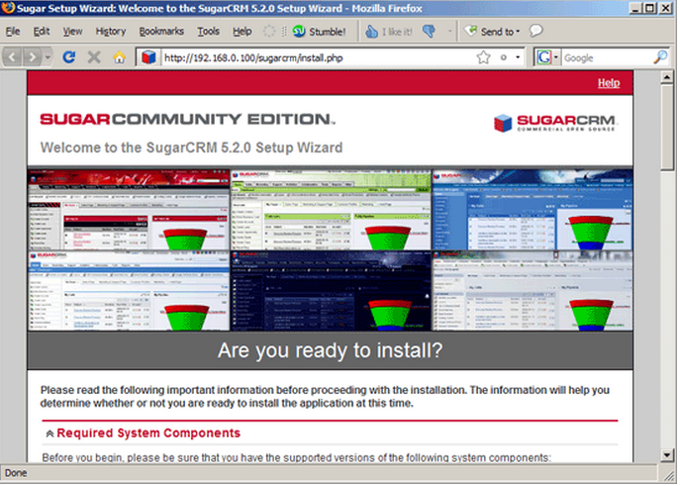
Scroll down and click on the Next button:
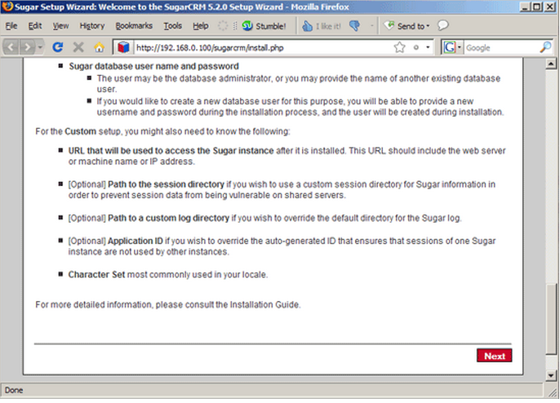
Accept the license (GPL) and click on Next:
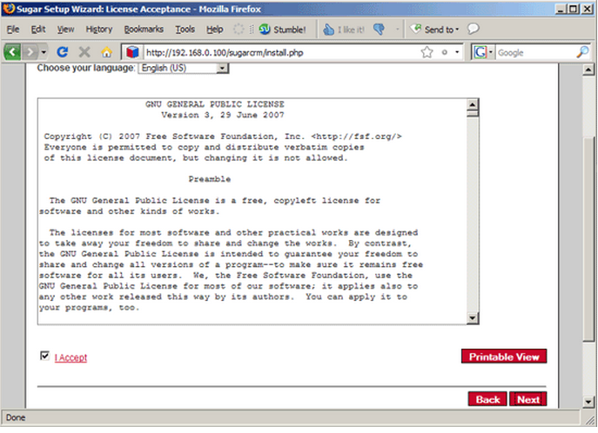
Select Typical Install and click on Next:
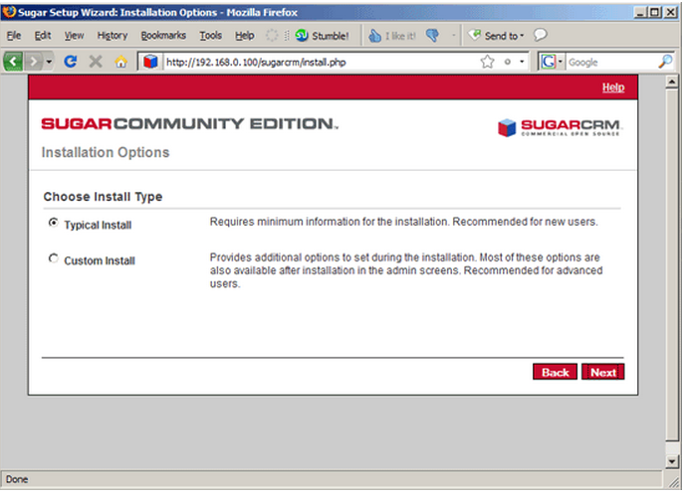
Select the database type (MySQL):
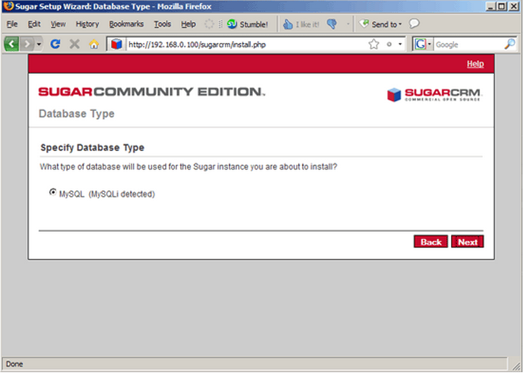
On the Database Configuration page, fill in a name for the SugarCRM database (e.g. sugarcrm) (will be created by the installer automatically if it doesn't exist). The Host Name islocalhost. Then fill in the username of the MySQL administrator (root) and his MySQL password (yourrootsqlpassword). Then scroll down...
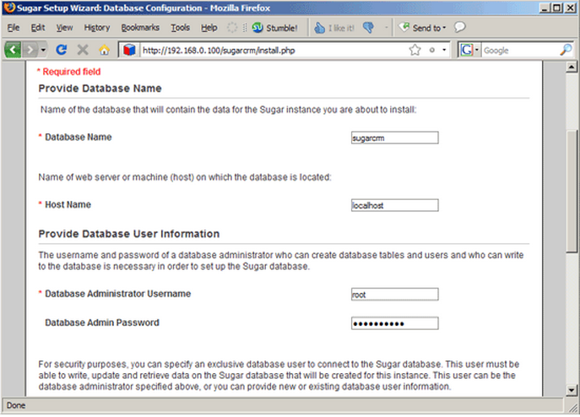
... and select Define user to create from the drop-down menu to create a MySQL user for SugarCRM (this user will be created by the setup wizard). Fill in a name for that user (e.g. sugarcrm) and a password. If you want to have some demo data to play with, select Yes from the Populate Database with Demo Data? drop-down menu. Click on Nextafterwards:
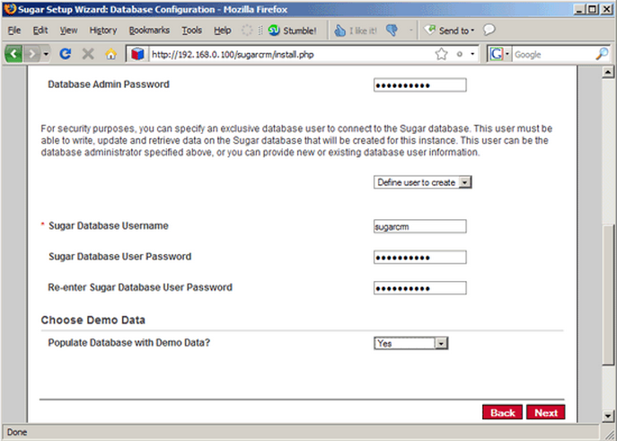
Next fill in a password for the SugarCRM admin user (username is admin):
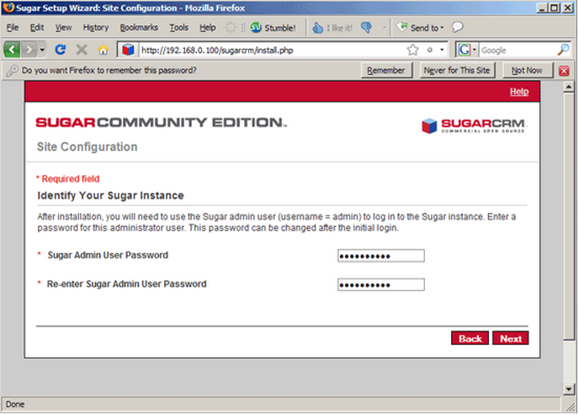
Select your locale and currency settings:
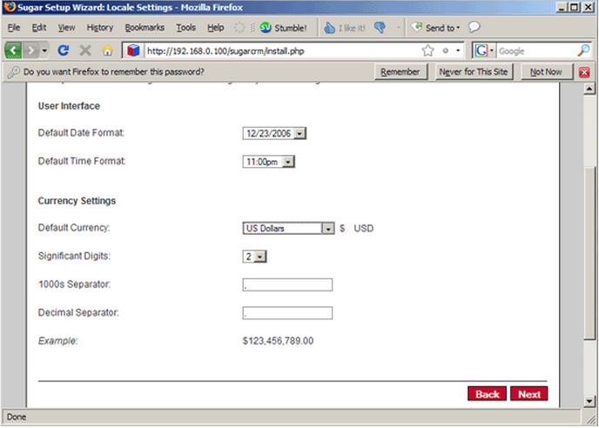
You should now see a summary of your selected options. If everything's ok, click on Install:
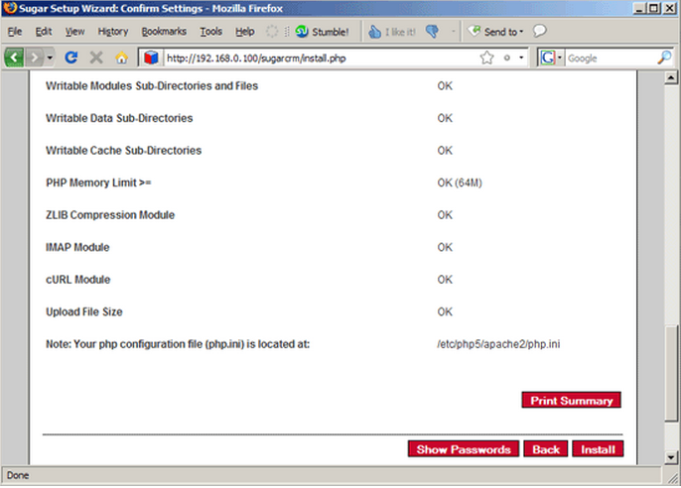
SugarCRM is now being installed. Click on Next afterwards:
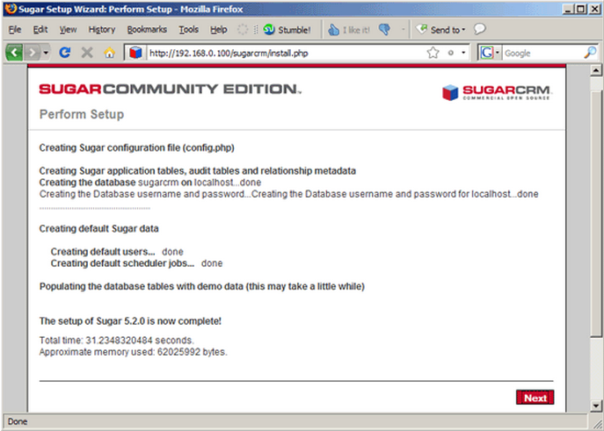
If you want you can now register to receive newsletters - this is optional:
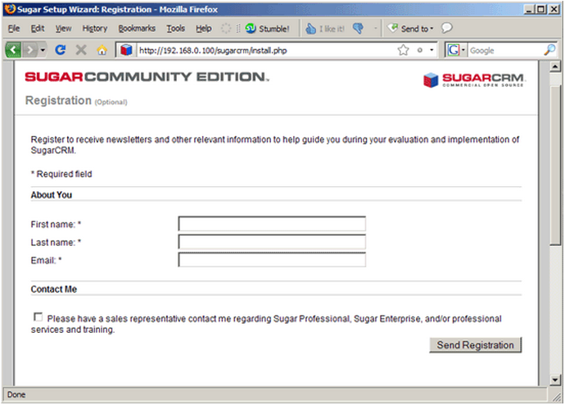
You should now see the SugarCRM login screen. Fill in admin as the username and the password you specified in the setup wizard:
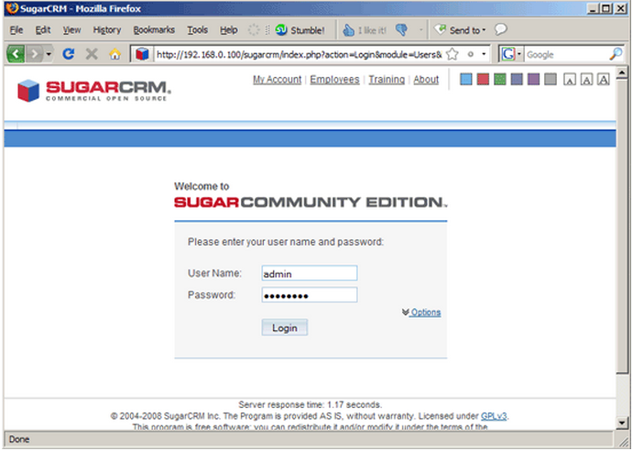
After the first login, you are asked to select your time zone. Select the right one and click on Save:
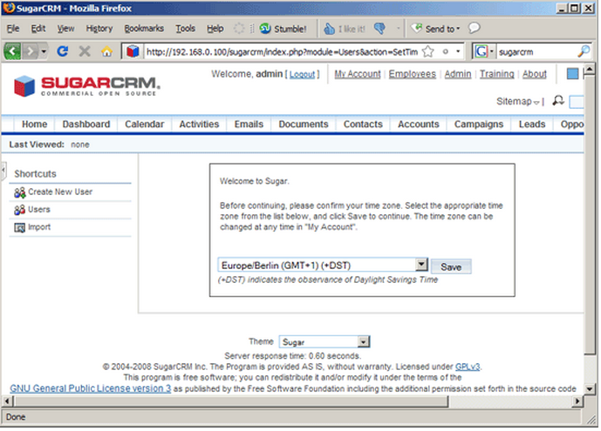
This is how sugarCRM looks:
